**Question 1.** R Project-Prepare a dataset and perform k-means clustering.

**Description:**

In this project we shall take a sample data set and use the unsupervised learning method on it. The sample set I chose was the Iris data set and we performed the K means clustering on it. In the k means clustering in R the data gets classified based on the few parameters like sepal and petal length where it groups data based on these parameters. The clusters denote the different species. In k means the clustering is done based mean value of the parameters. Given below is the screenshot of the result in R.

**Screen Shots:**

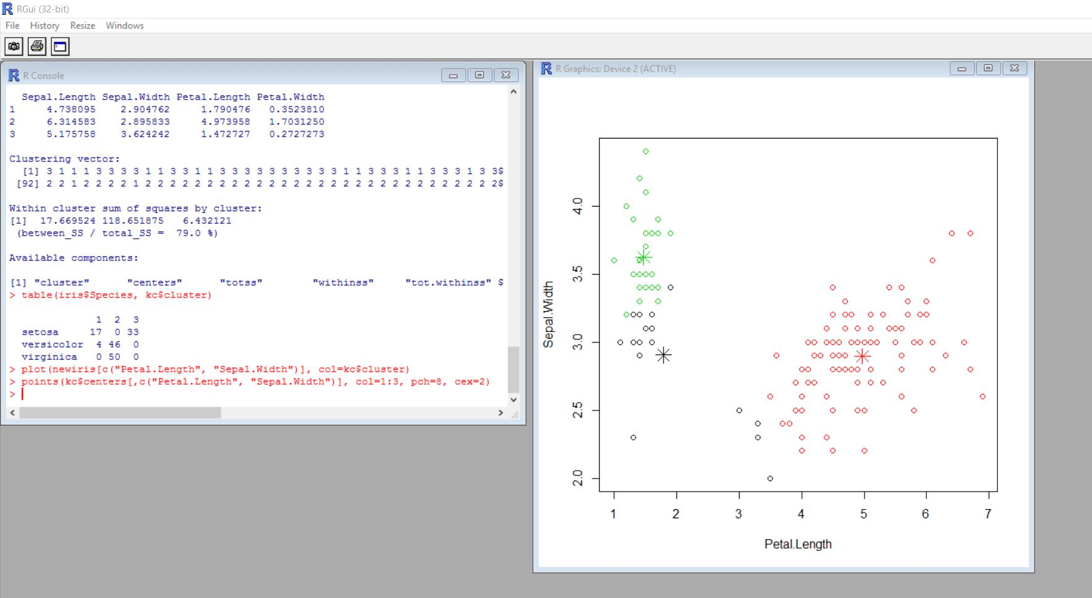

**Question 2.** RoboMe and Watch App-Create a RoboMe and Watch App that uses weather or any API of choice.

**Description:**

Here I have used a speech to text API. So as I operate the google speech services on my phone it convert it into a text as a speech and using the notification feature I send this recognized text to smart watch.

**Screenshots:**

